**USA Crime Analysis**

**USING MAP REDUCE:**

Q.No 1 part-I:

Map-Reduce program to calculate the number of cases investigated under each FBI code

Driver:

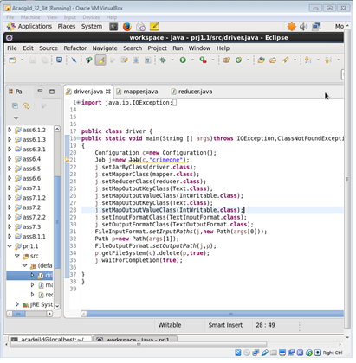

Mapper:

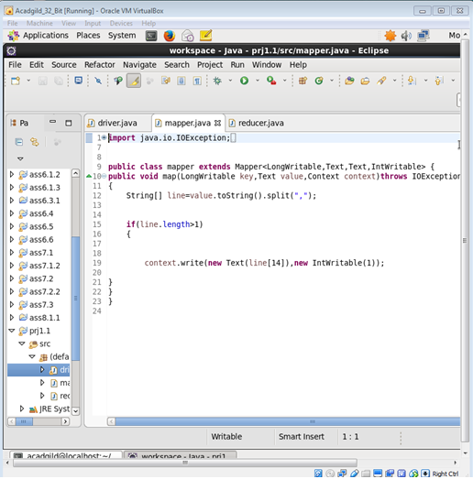

Reducer:

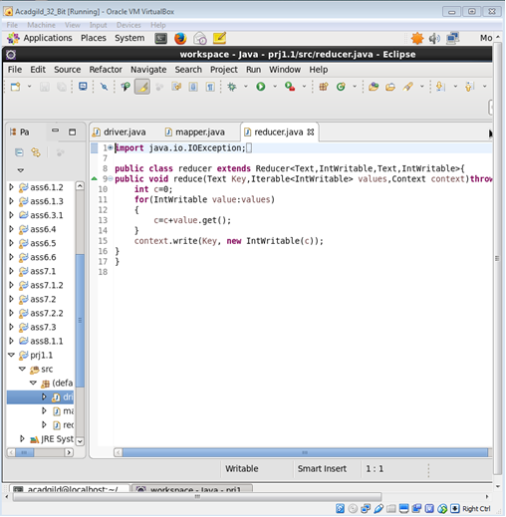

Running JAR file:

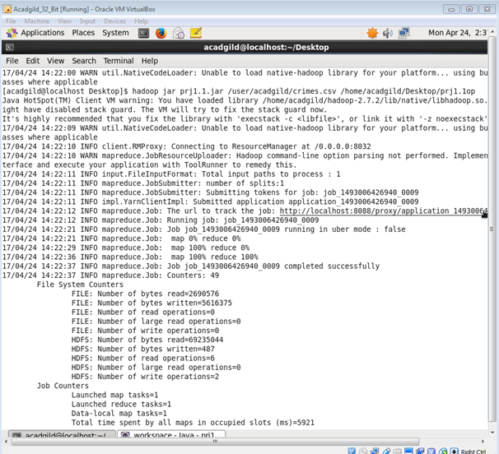

Output:

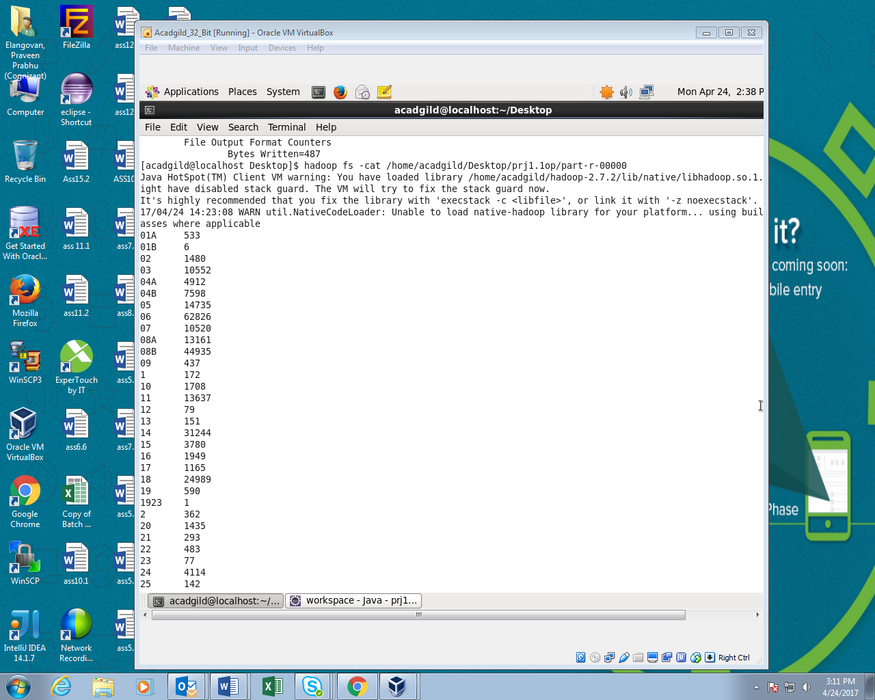

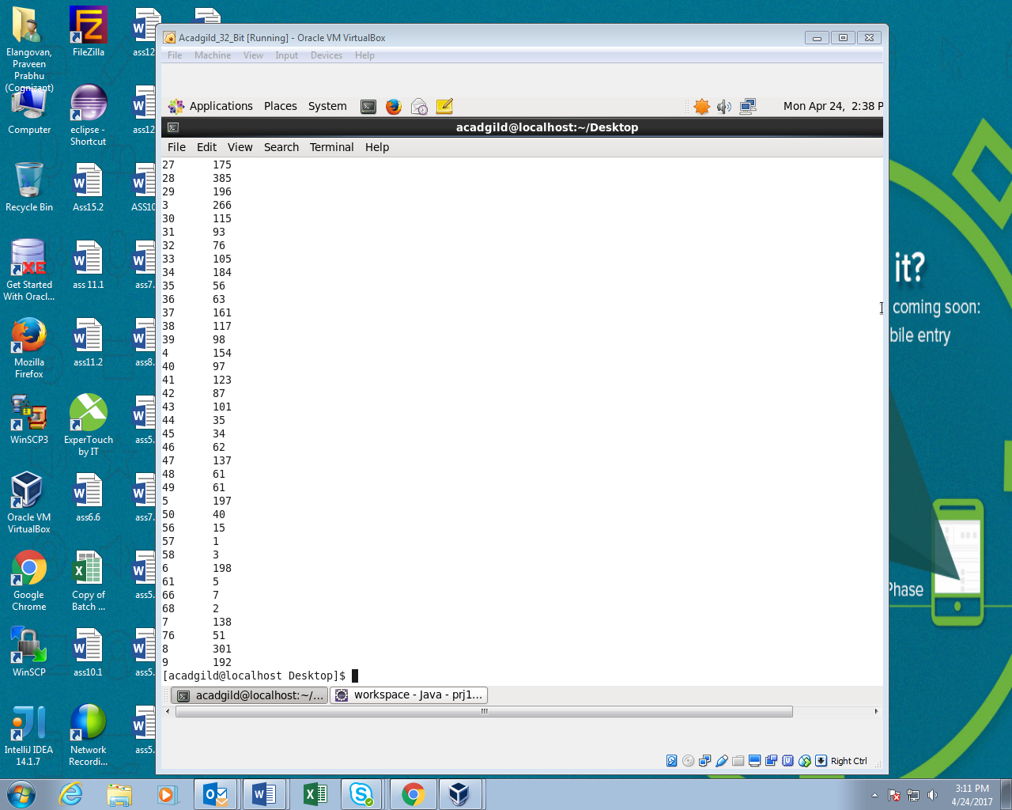

Qn.2 Part-I:

Driver:

Write the mapreduce program to calculate the number of cases investigated under FBI code 32.

Driver:

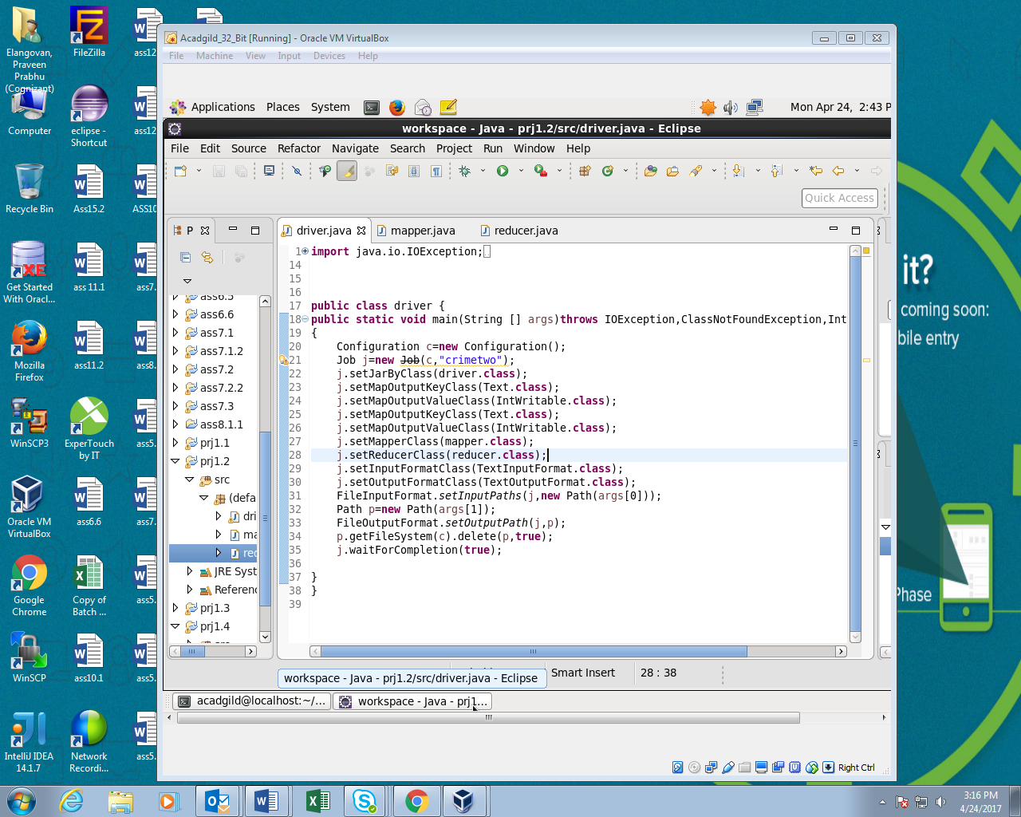

Mapper:

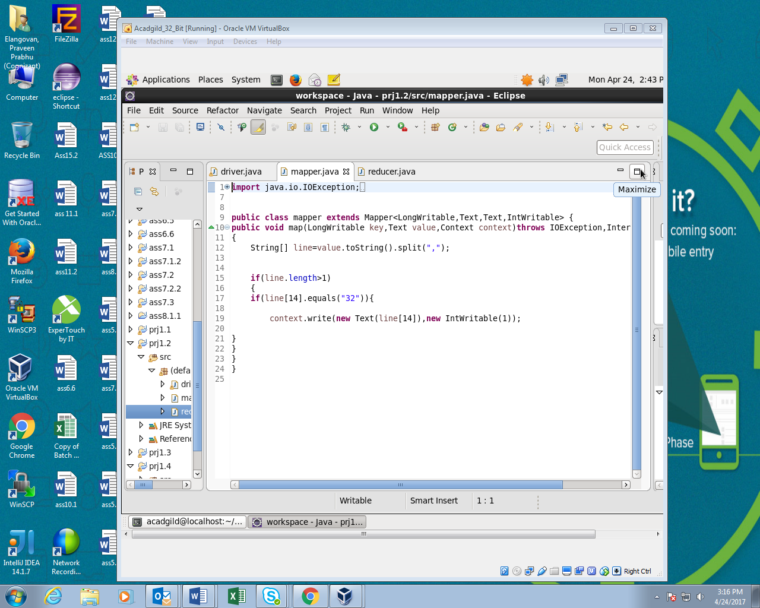

Reducer:

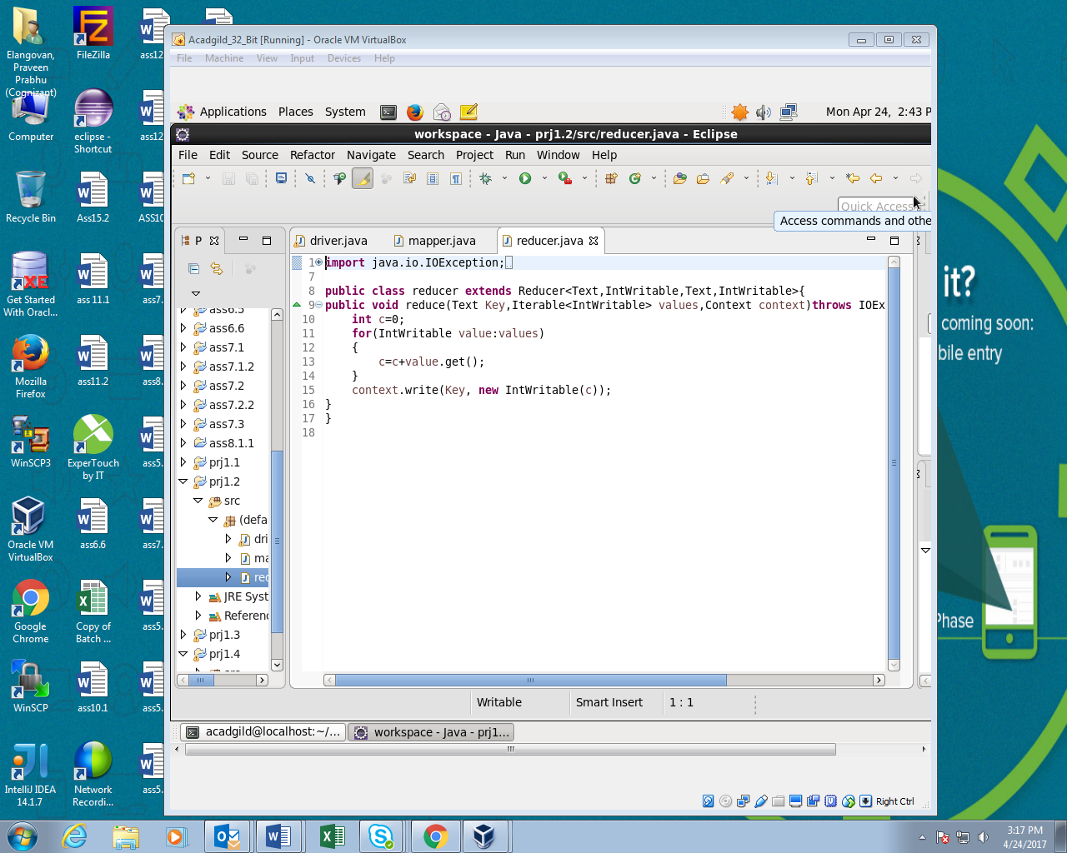

Running JAR file;

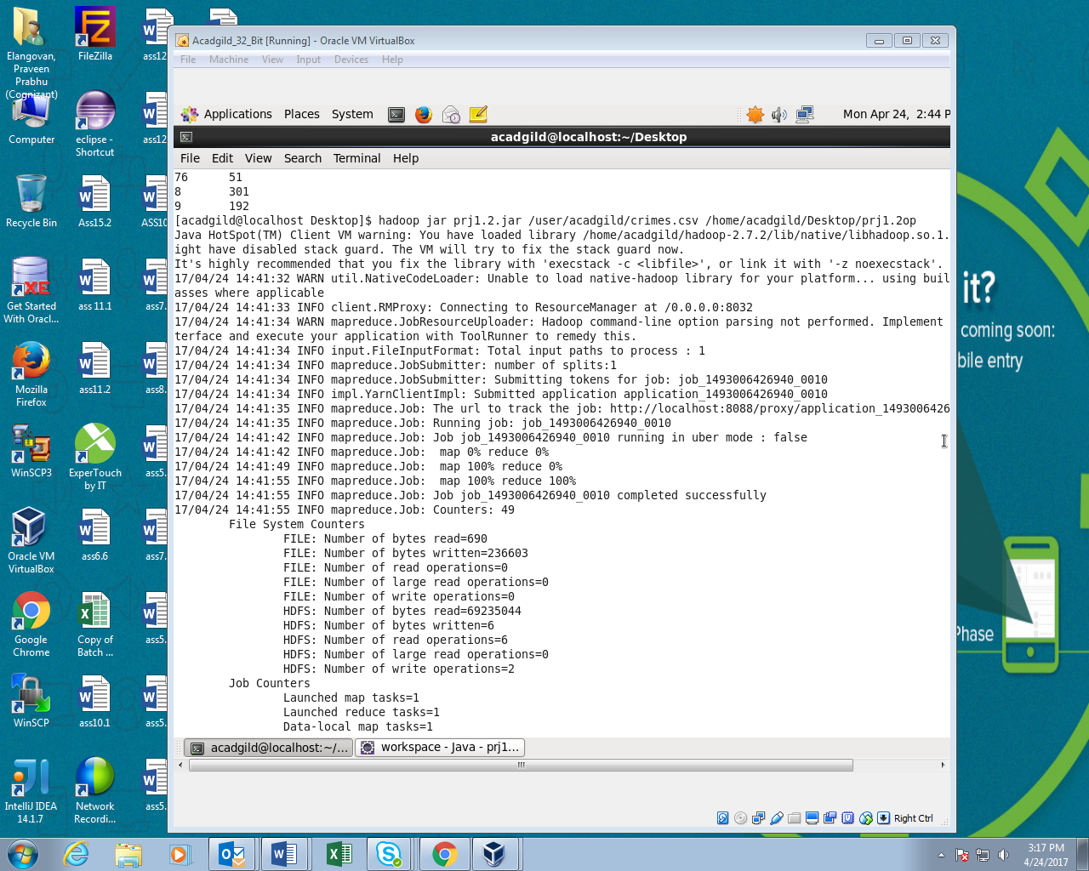

Output:

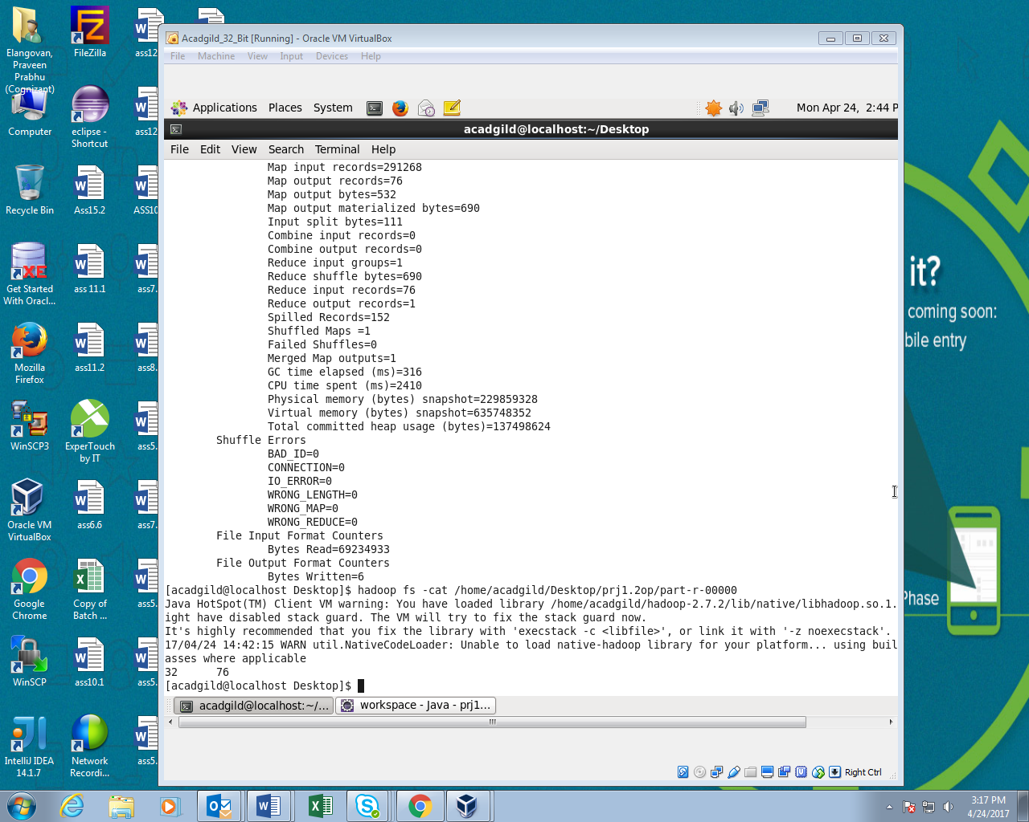

Qn.3 Part-I:

Write the map reduce program to calculate the number of arrests in theft district wise.

Driver:

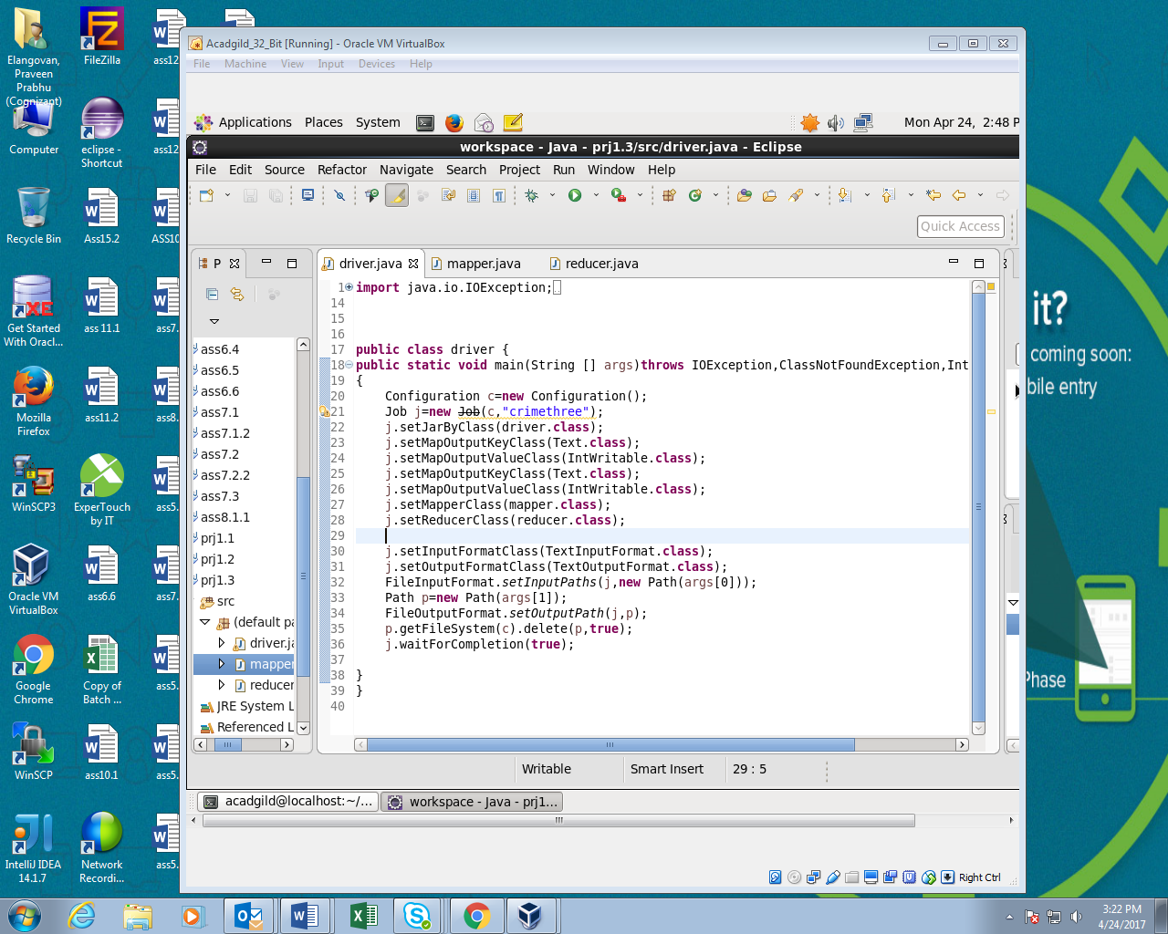

Mapper:

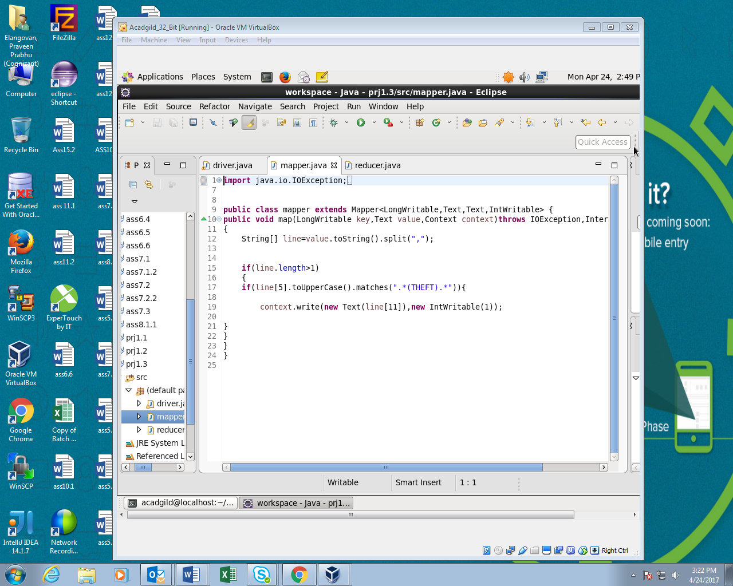

Reducer:

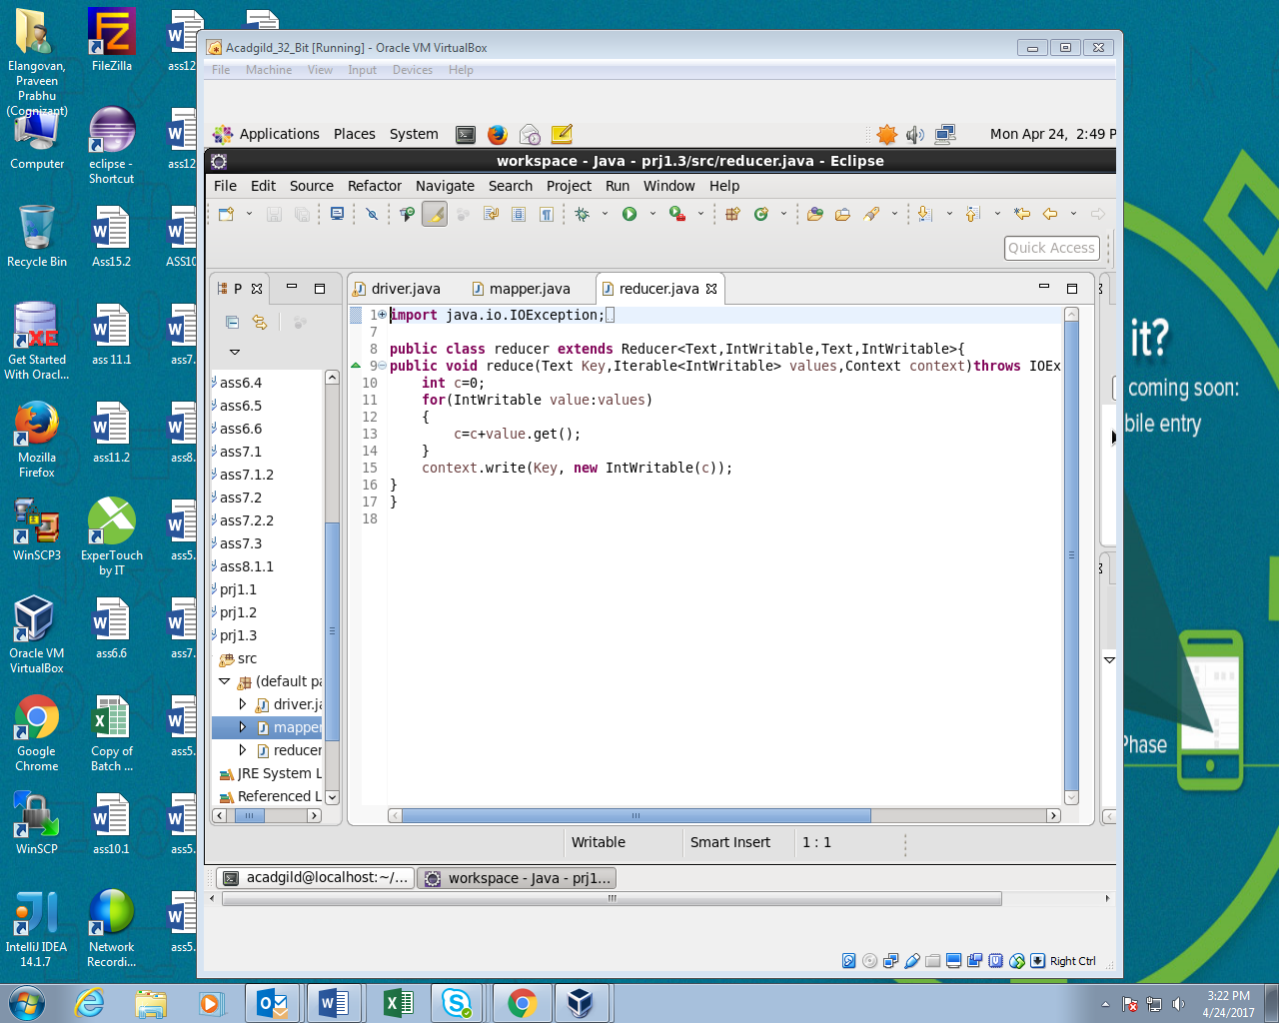

Runing JAR file:

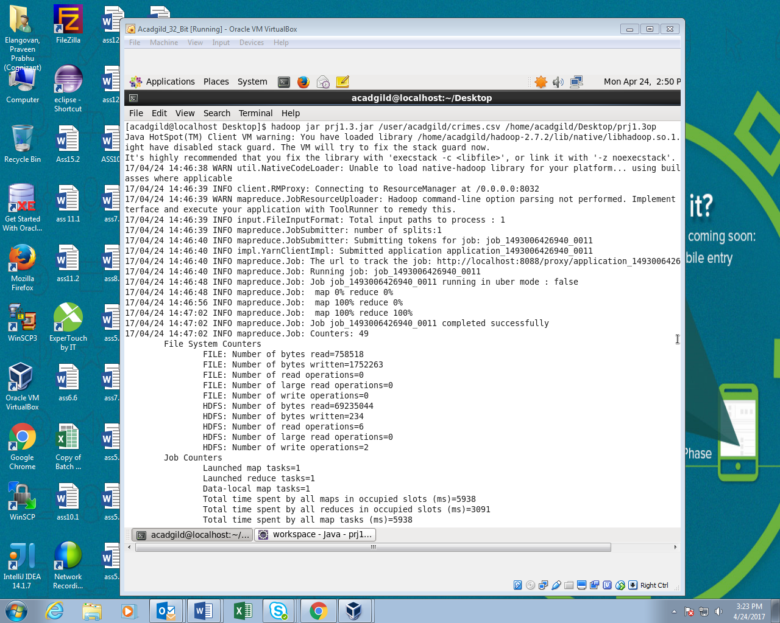

Output:

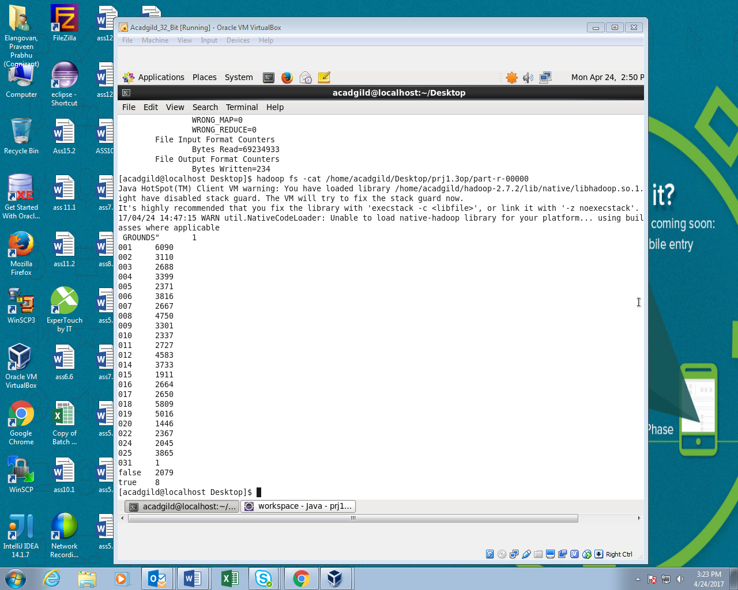

Q.no 4 Part-1:

Write the map reduce program to calculate the number of arrests done between October 2014 and October 2015.

Driver:

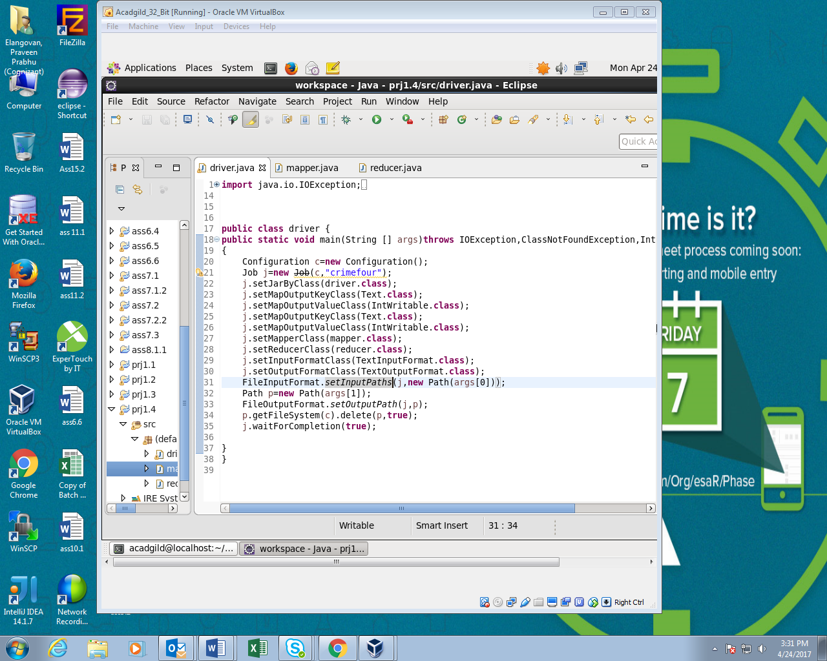

Mapper:

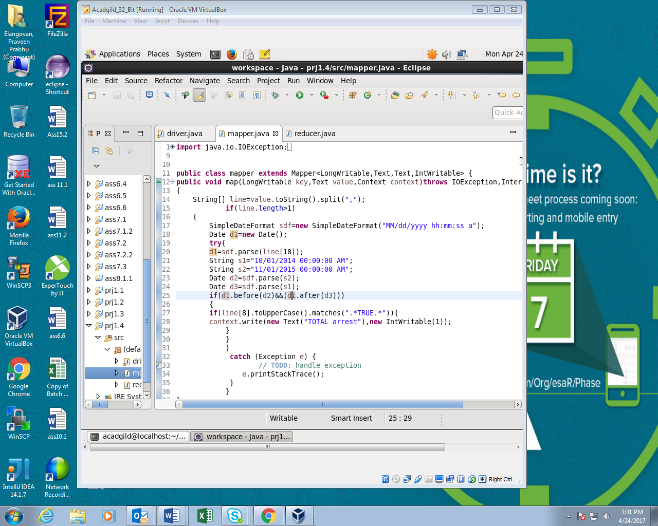

Reducer:

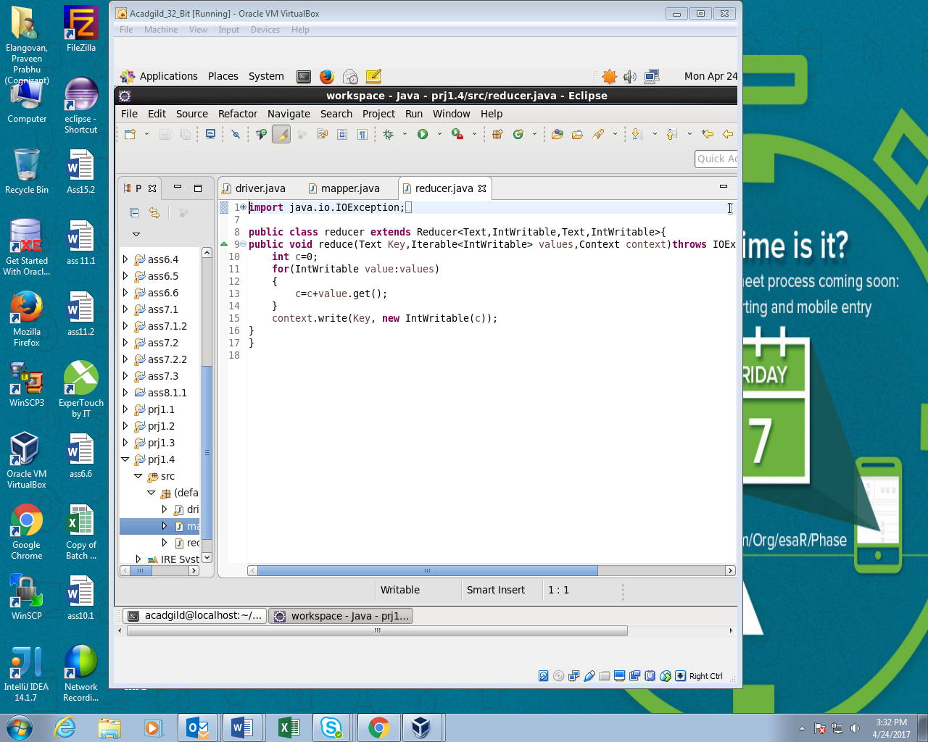

Running JAR file:

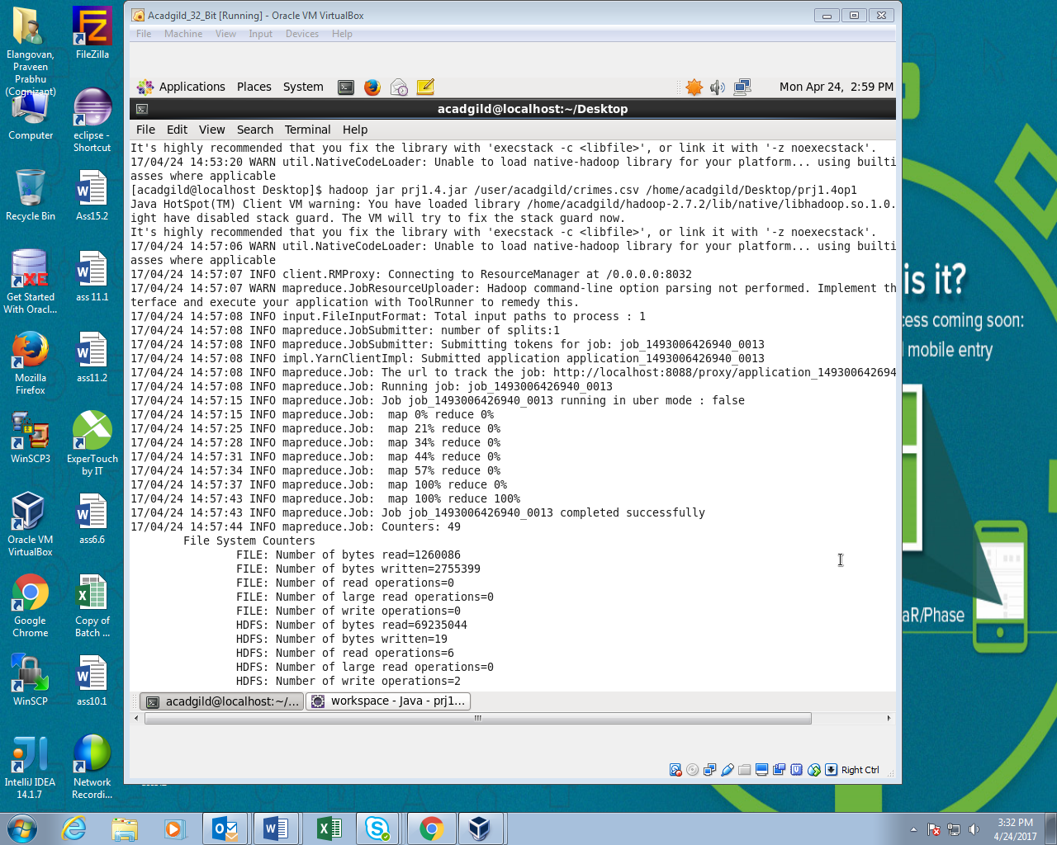

Output:

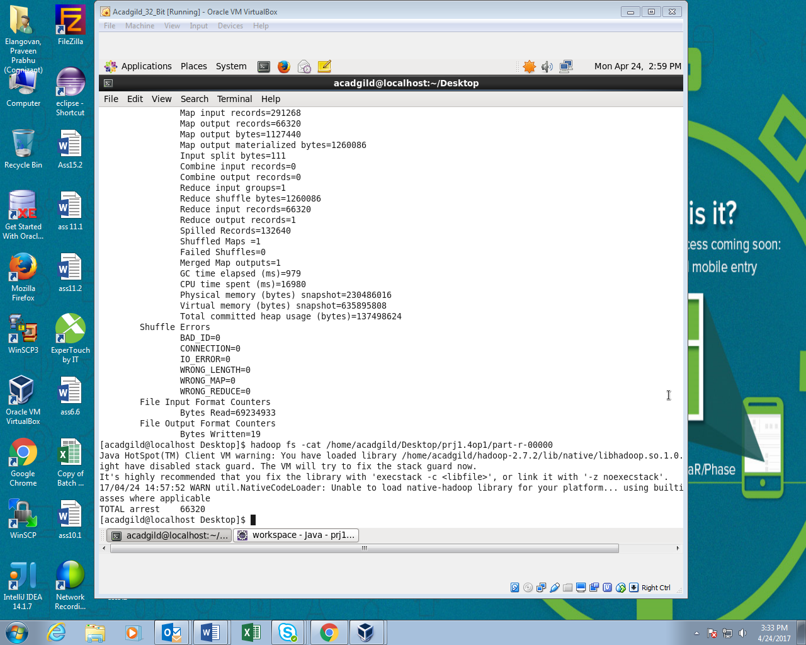

**USING PIG SCRIPT:**

Q.no1 Part-II Write a pig program to calculate the number of cases investigated under each FBI code

PIG command:

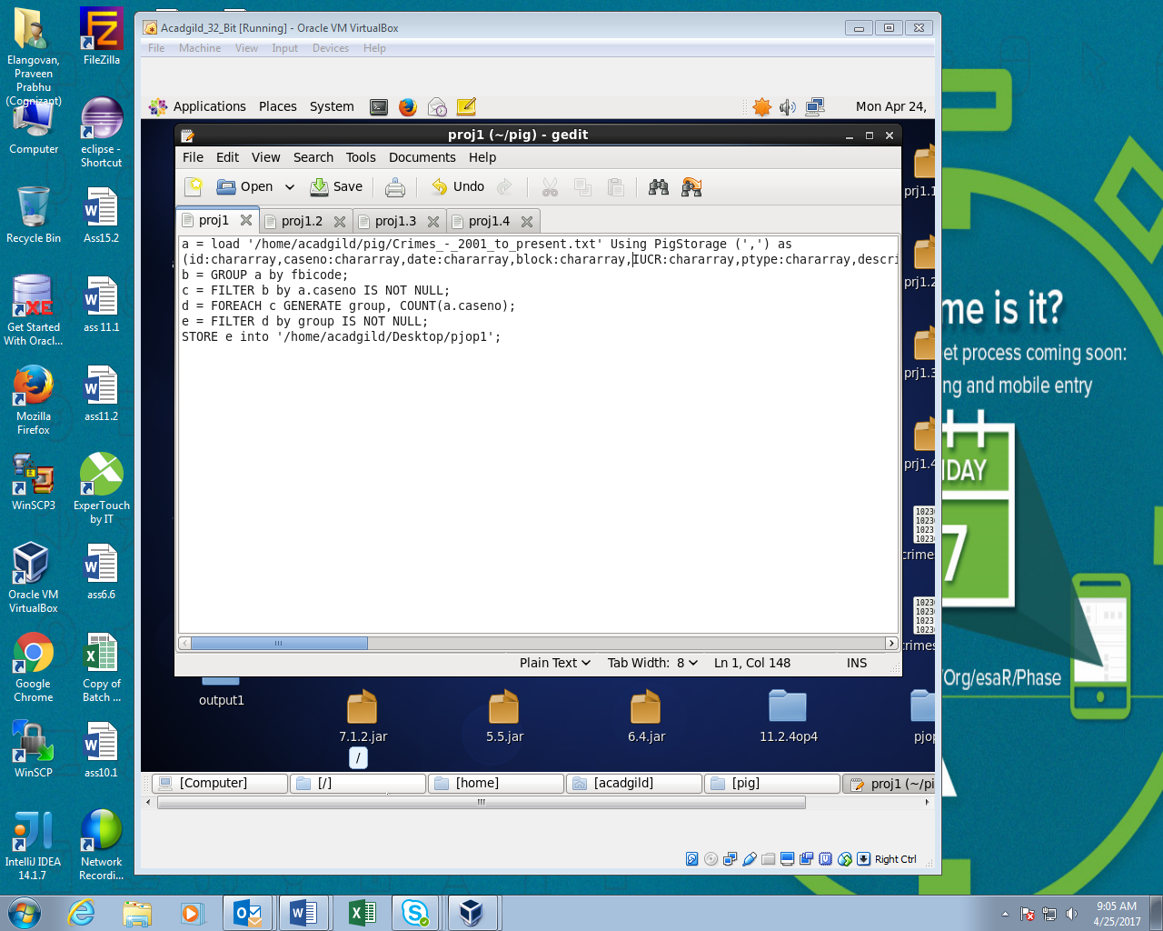

Running PIG script:

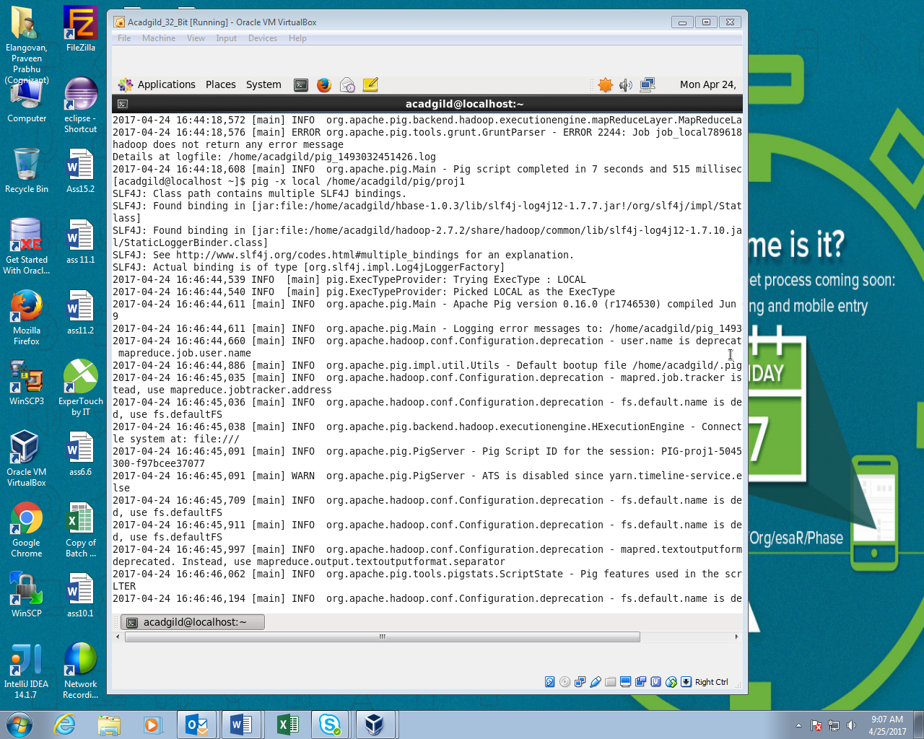

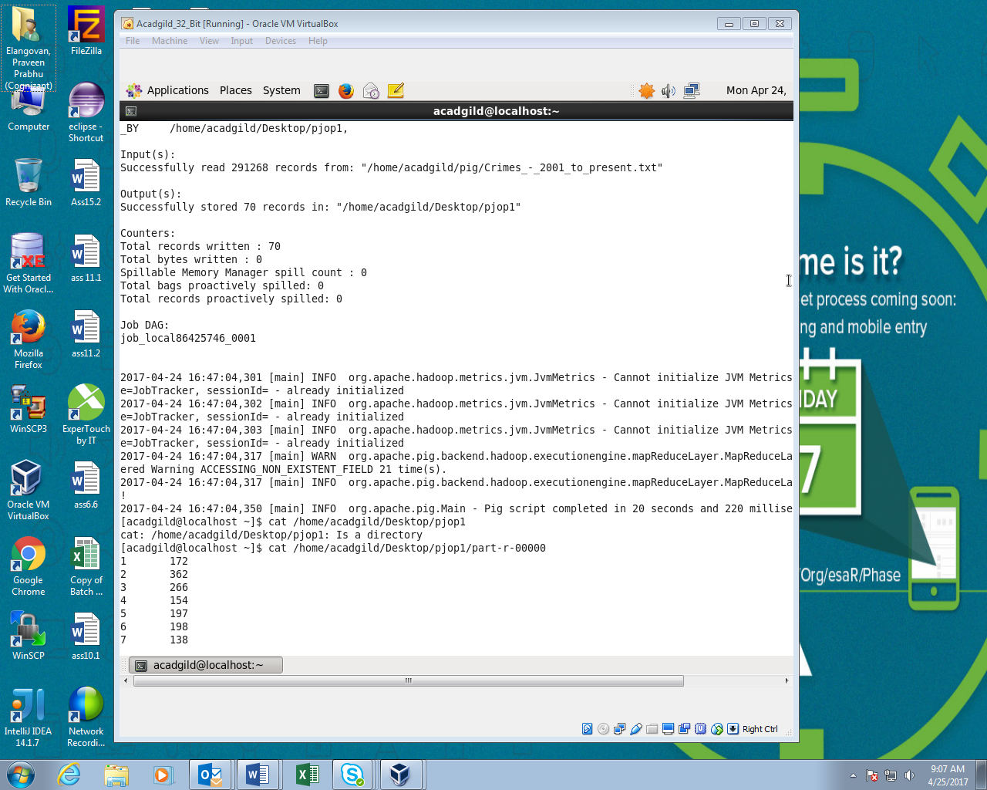

OUTPUT:

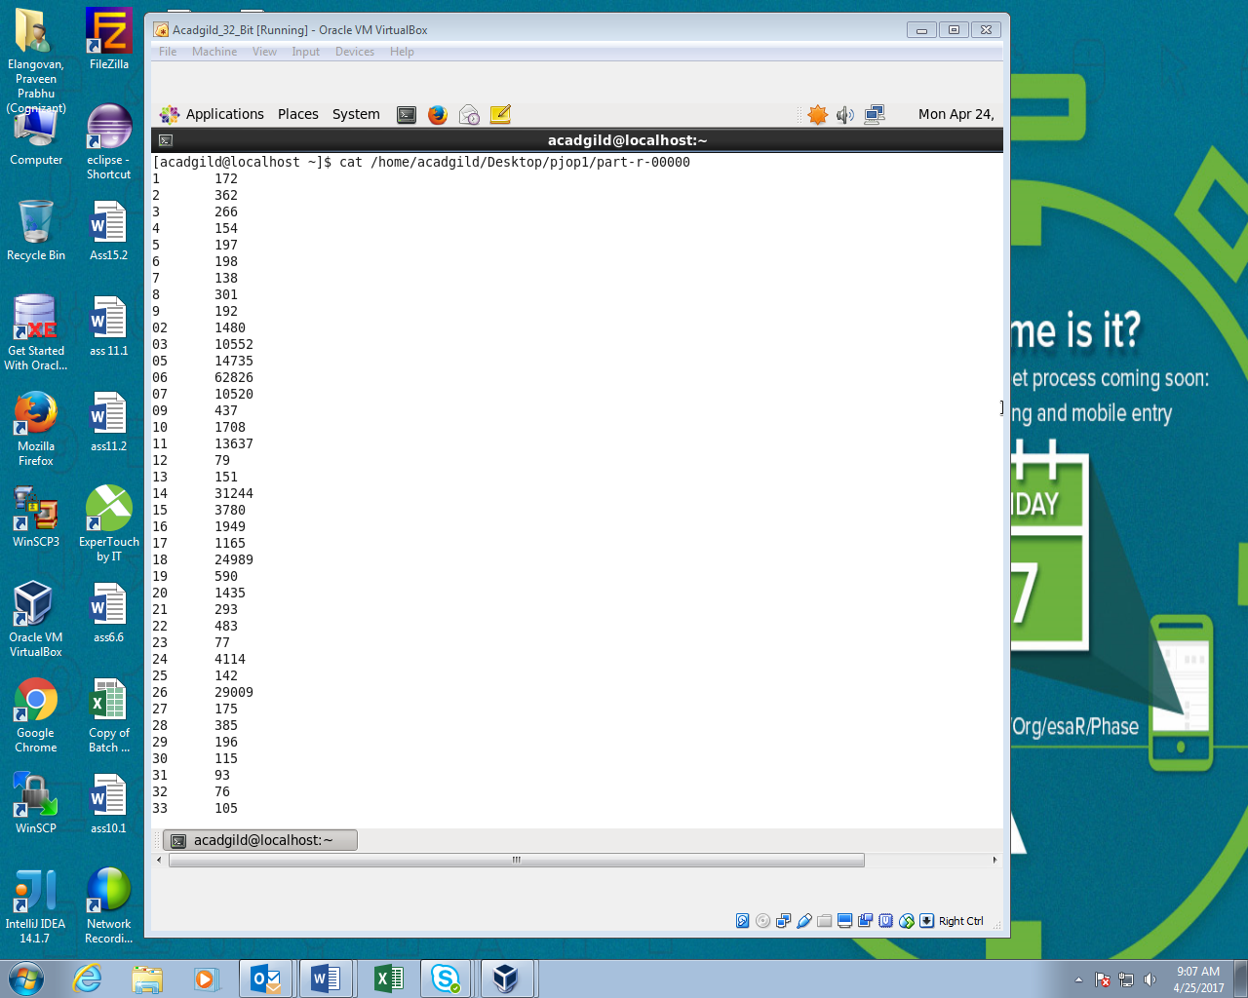

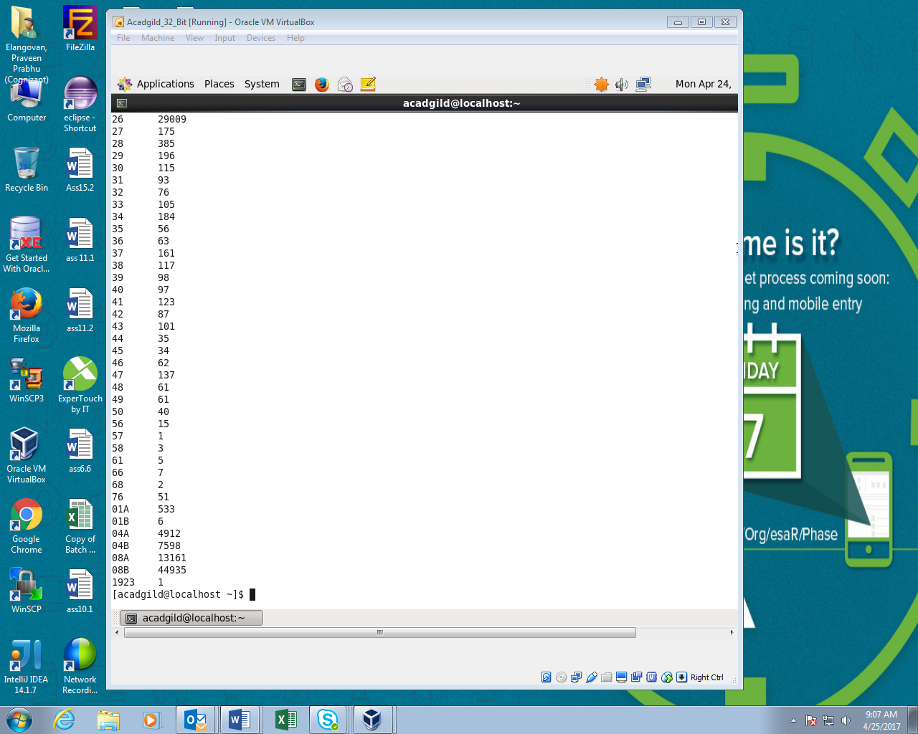

Q.No2 Part-II: Write and pig program to calculate the number of cases investigated under FBI code 32.

PIG command:

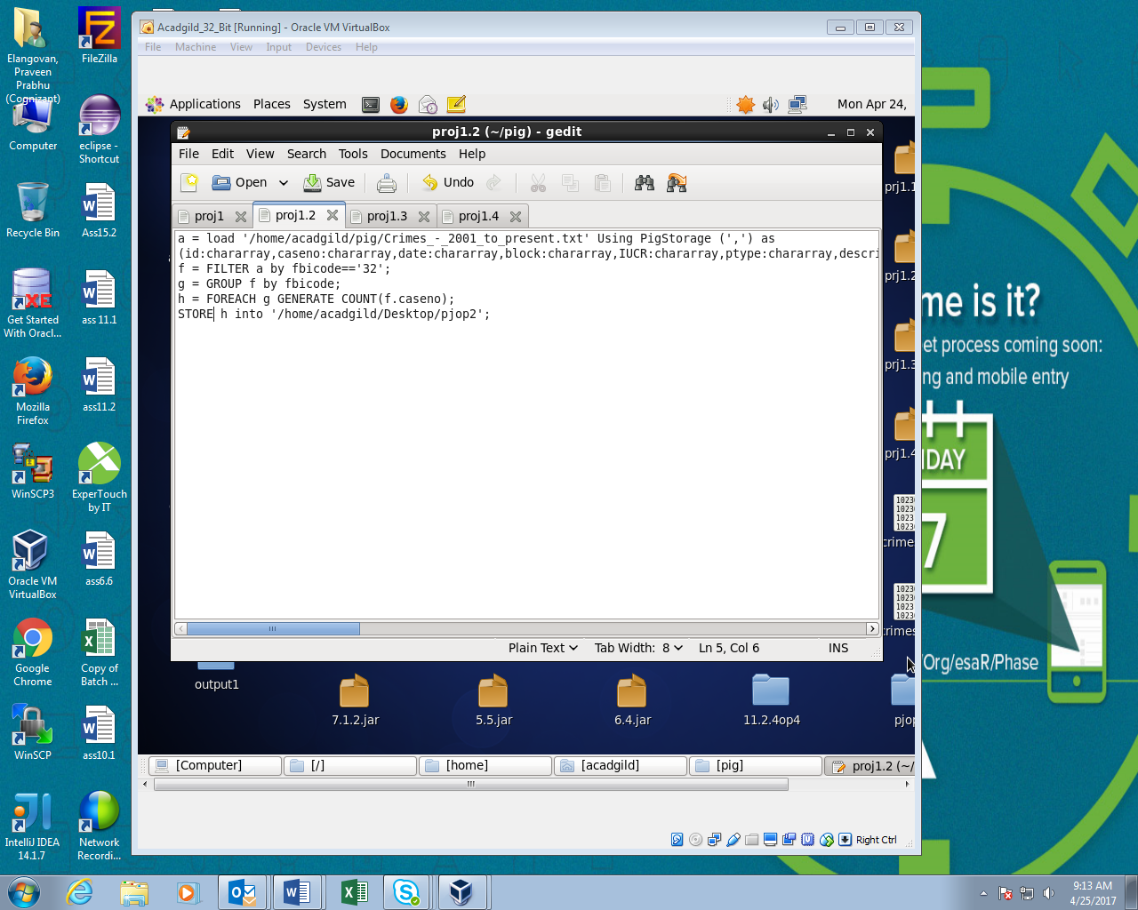

Running PIG script:

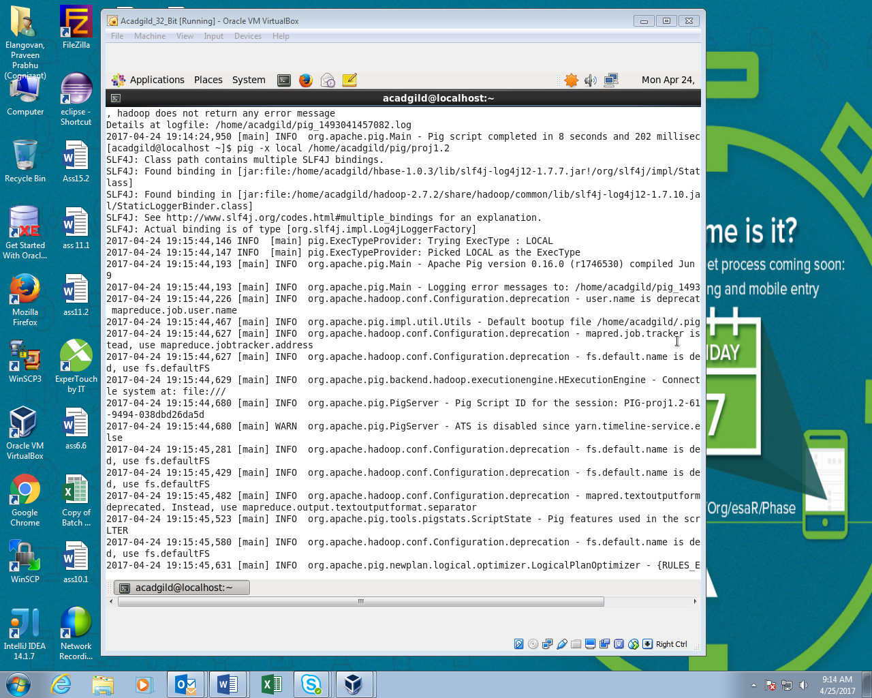

OUTPUT:

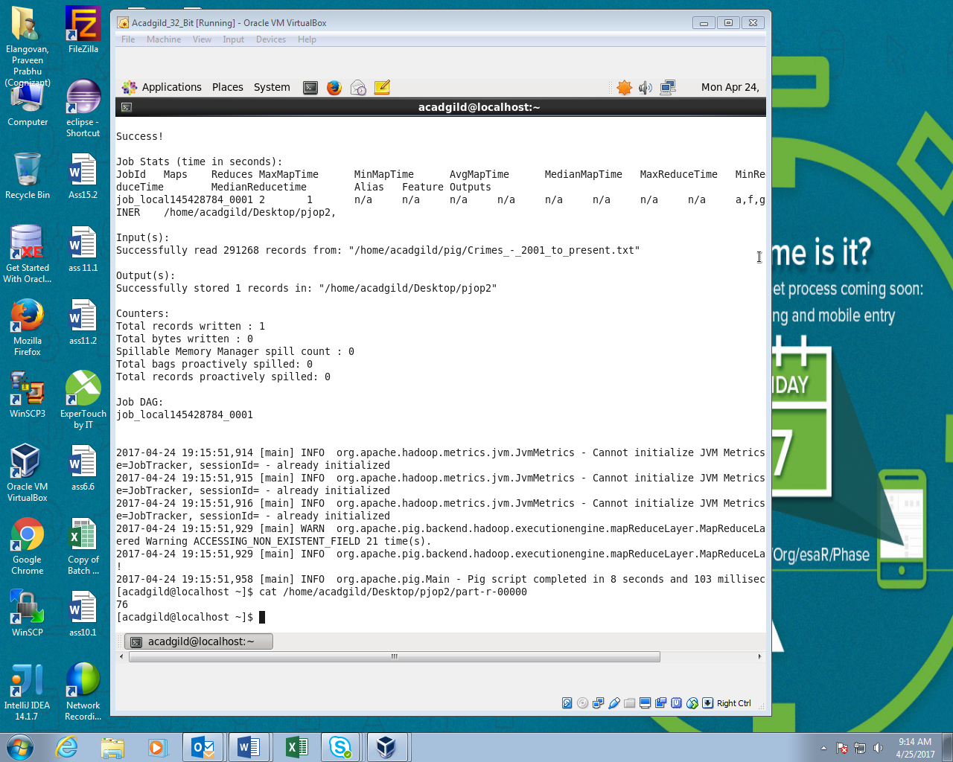

Q.No 3 Part-II: Write a pig program to calculate the number of arrests in theft district wise.

PIG script:

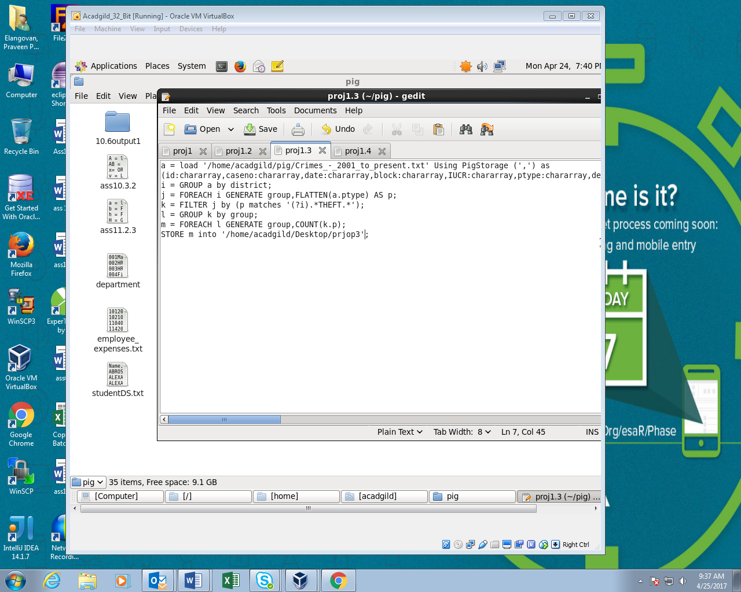

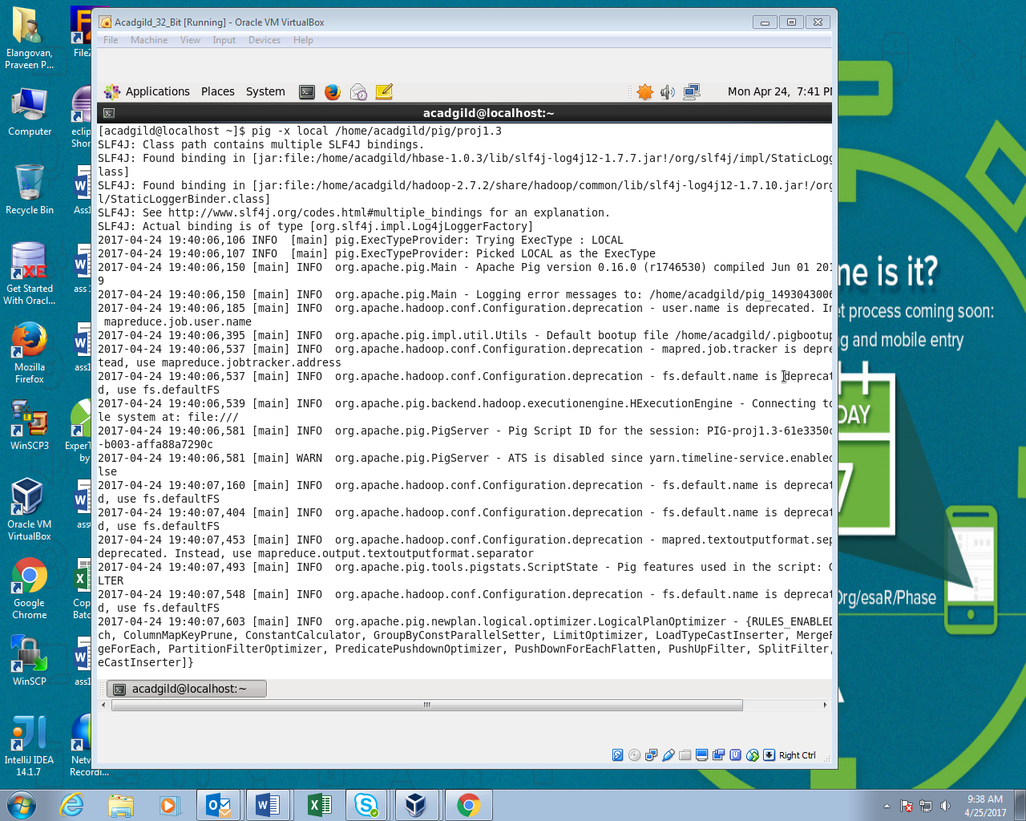

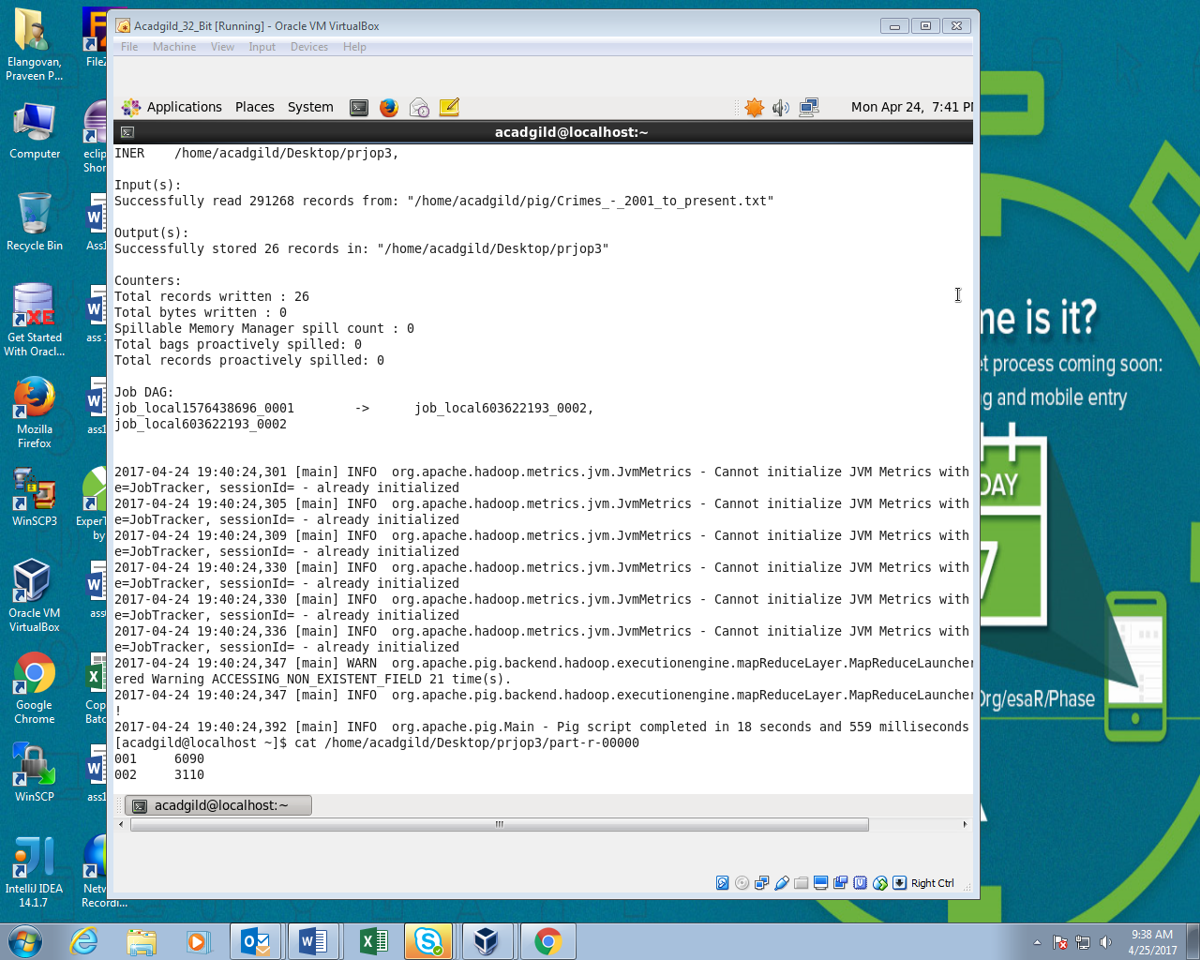

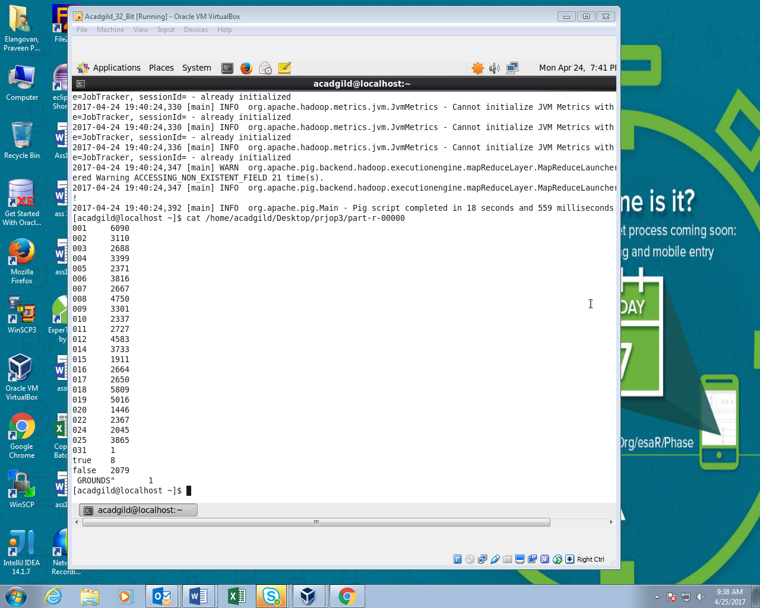

Q.No4 Part-IIWrite a pig program to calculate the number of arrests done between October 2014 and October 2015

PIG command:

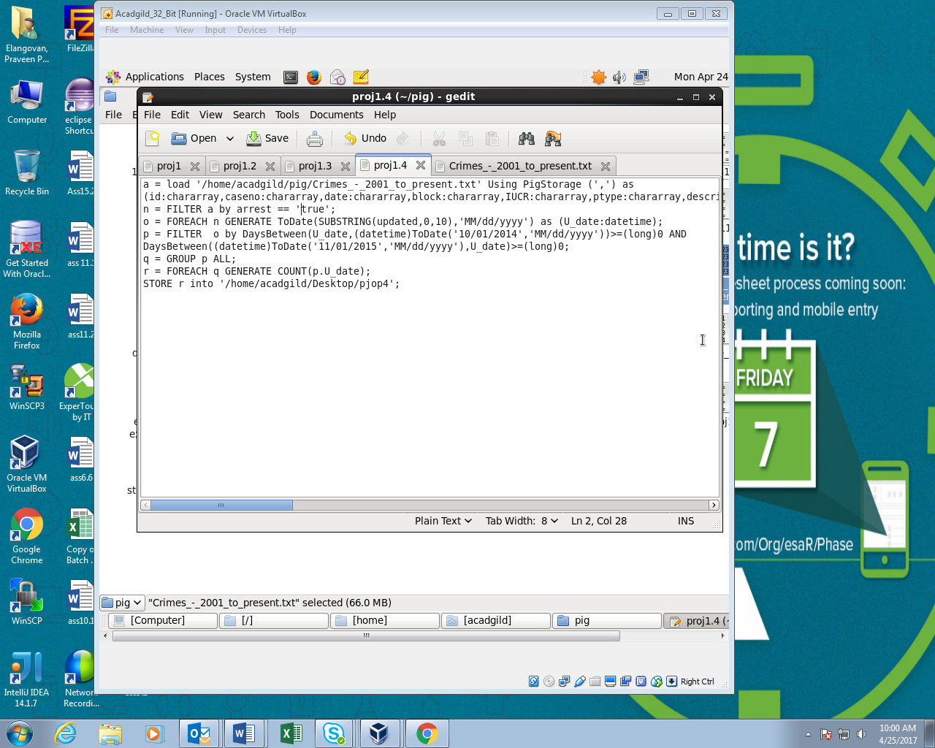

Running PIG script:

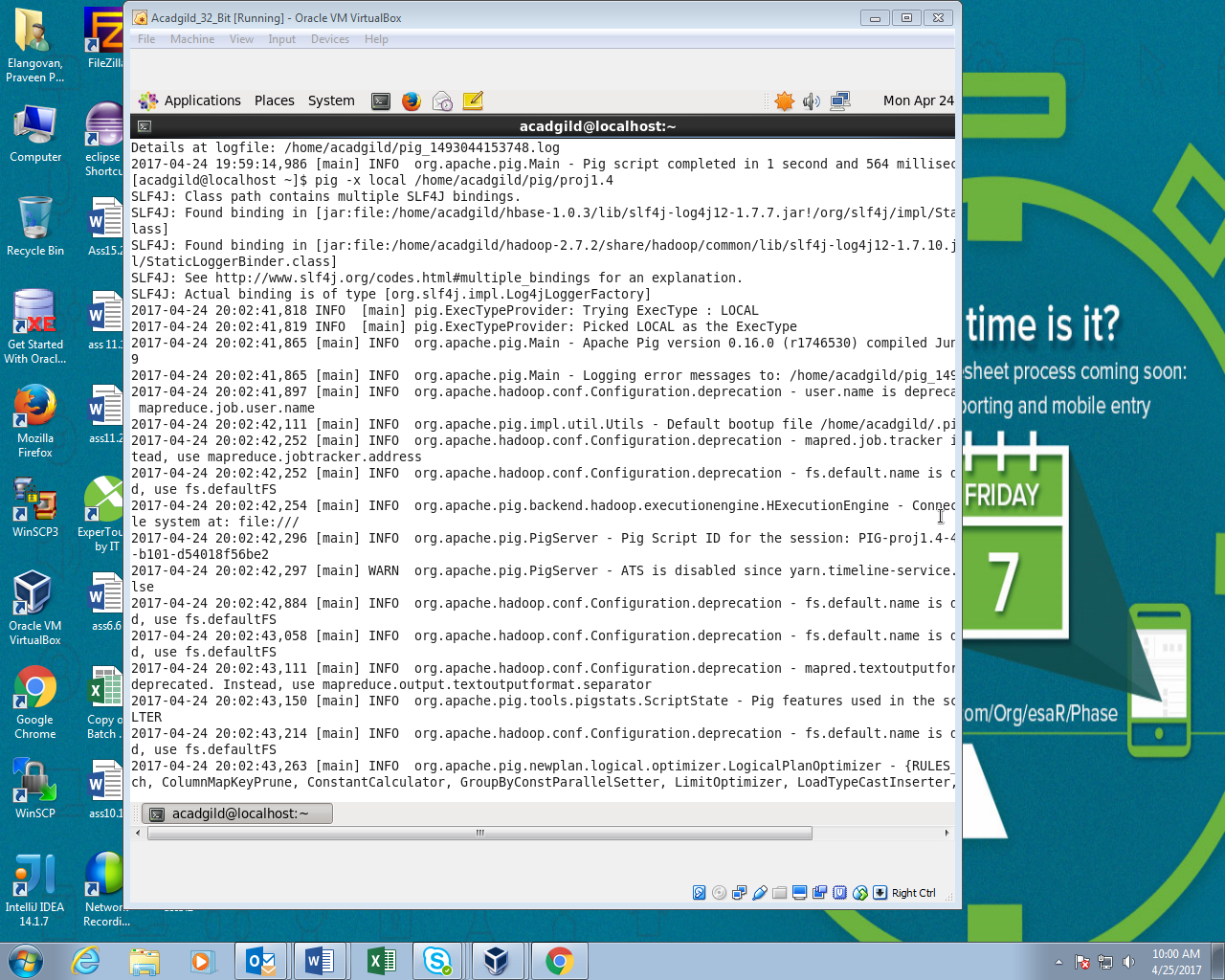

OUTPUT:

